Architecture Description

Functional View

System in Context
The purpose here is to show the new system in a global context. The objective is to identify the boundaries of the system in this environment and how the system interacts with external actors (applications or users). The system is seen as a black box.

The system is a Web Application defined in 3 layers frontend, backend and database. The technological setup is:
- Angular for the front
- Python with fastAPI in the back
- PostgreSQL for the database

In a functional point of view, the system has 4 modules:
- TIL (Trackable Item List): is the module where the user can upload LIL files, trace and manage all international updates (TAR) from the EF baseline of each Tranche are traced and control when it impacts in a national point of view.
- SBC (System breakdown Code): the TIL is defined with SBC + the life types in STP and LIL so this module allows the user to upload, trace and manage all the SBC versions. The SBC contains the trackable LCN-PNR that belongs to the TIL
- STP (Structural Trackable Parts): the STP contains the life type of some LCN-PNR (the structure ones) that belongs to the TIL. This module allows the user to upload, trace and manage all the SBC versions. The updates are sent to IETP team in order to uploaded into the EF Maintenance Plan System
- LIL: the LIL contains the life type of some LCN-PNR that belongs to the TIL. This module allows the user to upload, trace and manage all the LIL versions. The updates are sent to IETP team in order to uploaded into the EF Maintenance Plan System

In the database there is a schema for each module but they are able to communicate to each other.

DIAGRAM

The goal of this ARD is to deploy the Web Application in a production environment using a platform, based on Kubernetes, Docker images and OpenShift, in order to expose it to the intranet (NOT public internet) and manage it with a CI/CD workflow

Roles: admin, eng user and read only

System actors (Applications) | Functional Description
Frontend | The user interface (UI) that users interact with (e.g., forms, dashboards). Fetches data from the Backend via API calls. Renders dynamic content. Handles user input (e.g., form submissions).
Backend | The server-side logic that processes requests, interacts with the database, and returns responses. Exposes REST APIs for the frontend. Validates input, applies business rules, and queries the database. Manages authentication/authorization (e.g., JWT validation).
Database | The persistent storage layer that holds structured data. Contain all the schema from the system, ensure data integrity and supports cross-module queries
SSO | Single Sign On it is a centralized authentication system that lets users log in once to access multiple services. Eliminates separate logins for each module. Use standard OAuth 2.0 with Password Flow (JWT)  In the future could be integrated with Active Directory
Security
File management | Current version does not have file management the system only contains several libraries such as “access-parser” to import/export the fields into or out to the database. The goal of future releases is to manage file repositories using the DCS platform

  - System architecture
This section presents the architecture as a whole.

Architecture breakdown
This section presents the hierarchical structure of components part of the System of Interest.
System component | System component description | System sub-component | System sub-component description
Code details
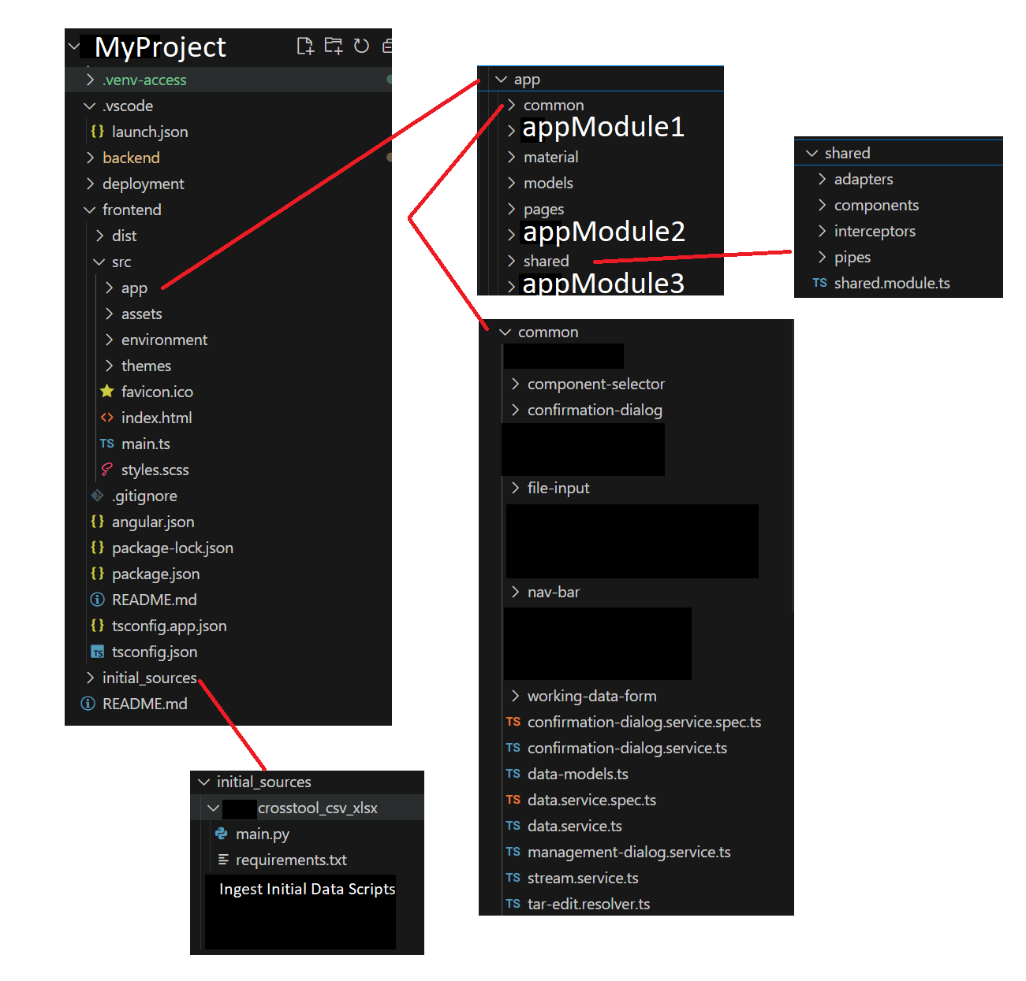
Deployed in platform based in Kubernetes with docker images and manage with openshift:
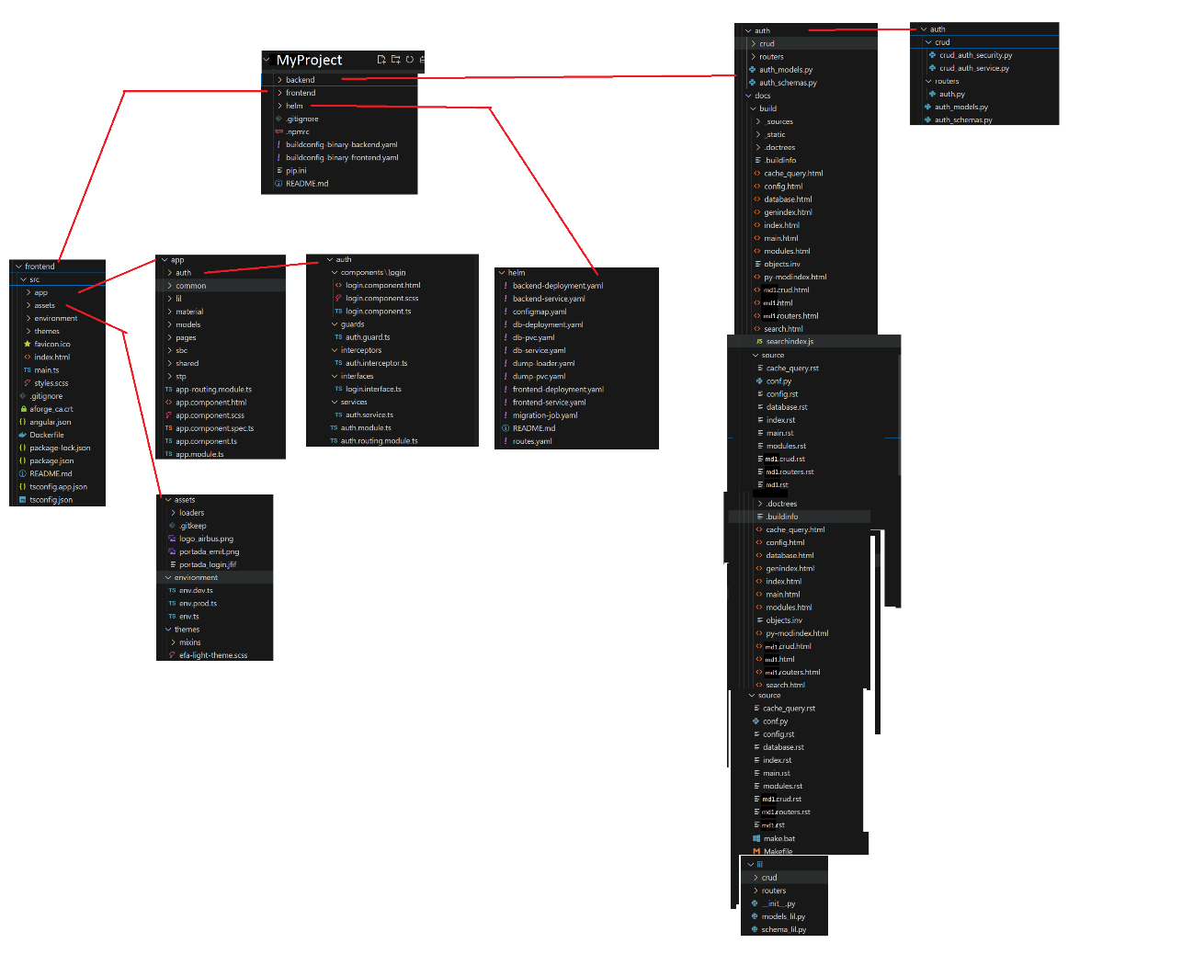

IAM View
This paragraph focuses on particular aspects of the architecture, such as Identity & Access Management (IAM) and SSO.

Authentication
The purpose of this paragraph is to present the standard way for: how a user is identified and how system log on works. E.g., Active Directory integration
<Insert text>

Authorization
The purpose of this paragraph is to present how a role-based access control is established inside the system to ensure the need-to-know principle.
<Insert text>

